AutoFixer: LLM-Guided Program Repair for Java Using Neuro-Symbolic and Multimodal Code Reasoning
Elanthiraiyan S B, Keerthivasan G, Manish Mohan, Mohamed Ammar
Department of Computer Science and Engineering, Panimalar Engineering College, Chennai, India

Abstract—This paper presents AutoFixer, a neuro-symbolic automated program repair system for Java that combines Large Language Models (LLMs) with formal symbolic verification. Existing LLM-based repair systems suffer from the “plausible but incorrect” patch problem due to the absence of formal verification. AutoFixer addresses this through a three-component architecture: a Multimodal Analysis Engine integrating compiler diagnostics, Abstract Syntax Trees (AST), and Control Flow Graphs (CFG); an LLM Integration Module leveraging Qwen2.5-coder:3b served locally via Ollama; and a Symbolic Validation Layer using the Z3 theorem prover. The system executes an iterative repair loop of up to 4 cycles, re-verifying each generated patch through compilation, 2-second runtime timeout testing, and symbolic checks before acceptance. Deployed as a Flask-based Python backend with a plain HTML/JavaScript frontend and local file-system project storage, AutoFixer requires no cloud infrastructure. System testing across 40 test cases covering unit, integration, API, and end-to-end scenarios confirmed correct detection and repair of infinite loops, incorrect variable initialization, and missing loop update patterns.
Index Terms—Automated program repair, neuro-symbolic AI, large language models, Z3 theorem prover, Java, control flow analysis, formal verification.

I. Introduction
Software development is a complex process where programming errors are inevitable, often leading to system failures, security vulnerabilities, and significant financial losses. Automated Program Repair (APR) has emerged as a promising research area to automatically identify and fix bugs in software programs.
Early APR approaches relied on genetic programming and search-based techniques, which often produced patches that passed test cases but lacked semantic correctness. Large Language Models (LLMs) have completely transformed this field. Still, LLM-based repair systems run into real problems—no formal verification, not enough understanding of context, and no clear way to explain their solutions. AutoFixer steps in to fix these gaps.
It uses neuro-symbolic reasoning and multimodal code analysis, blending the creative side of LLMs with the strict logic of formal verification through the Z3 theorem prover. The result? Repairs that are not just inventive but also correct.
II. Related Work
A. Traditional Program Repair
Weimer et al. [1] introduced GenProg, using genetic programming to automatically repair C program defects, though it suffered from generating “plausible but incorrect” patches. Kim et al. [2] developed Par with template-based mutations for improved patch quality. Le et al. [3] contributed history-driven repair mining version histories to guide patch generation.
B. Search-Based and Constraint-Based Approaches
Nguyen et al. [4] introduced SemFix using symbolic execution and constraint solving for semantically correct patches. Mechtaev et al. [5] developed DirectFix handling multiple bugs simultaneously via angelic execution. Yuan et al. [6] proposed ARJA applying multi-objective genetic programming for Java programs.
C. Template-Based Repair
Martinez and Monperrus [7] demonstrated that a significant percentage of real repairs follow predictable patterns. Kim et al. [8] extracted repair templates from version control histories. Long and Rinard [9] developed Prophet using probabilistic models to rank candidate fixes from learned human patch patterns.
D. LLM-Based Program Repair
Chen et al. [10] demonstrated models trained on large code corpora could generate syntactically correct patches. Jiang et al. [11] showed fine-tuned LLMs achieve state-of-the-art repair performance. Xia and Zhang [12] explored ChatGPT and GPT-4 for conversational repair. Jimenez et al. [13] introduced SWE-agent combining LLMs with software engineering tools for real-world GitHub issues.

E. Neuro-Symbolic and Multimodal Approaches
Yan et al. [14] proposed Neural Program Repair combining neural networks with symbolic execution validation. Chakraborty et al. [15] investigated deep learning for vulnerability detection. Wang et al. [16] introduced FixMiner mining relevant fix patterns. Tufano et al. [17] showed code comments and commit messages improve patch relevance. Ahmed et al. [18] demonstrated multimodal analysis better understands intended program behavior. Zhang et al. [19] combined static analysis, dynamic traces, and natural language for comprehensive bug analysis.
F. Evaluation Benchmarks
Just et al. [20] introduced Defects4J as the standard Java repair benchmark. Lin et al. [21] developed QuixBugs for multilingual evaluation. Ye et al. [22] conducted large-scale empirical comparisons. Qi et al. [23] identified the overfitting problem in patch generation. Monperrus [25] identified key challenges including the oracle problem and scalability issues.
III. Limitations of Existing Systems
Current automated program repair systems have four big problems. First, most tools churn out patches that look good in tests but break down in real-world use—there’s no formal guarantee they’re actually correct. Third, neural-based approaches don’t explain their choices, which leaves developers guessing and makes it harder to trust the fixes. Fourth, they usually stick to just the source code text, ignoring all the extra context and information available in today’s development environments. These gaps are exactly why we designed AutoFixer the way we did.
IV. Proposed System: AutoFixer
AutoFixer is a neuro-symbolic automated program repair system addressing existing limitations by integrating LLMs with formal symbolic verification. Its core innovation eliminates the “plausible but incorrect” patch problem by ensuring every generated patch undergoes formal verification before being returned to the developer.
A. System Architecture
AutoFixer employs a three-component modular architecture supported by a Flask-based Python backend and plain HTML/JavaScript frontend with local file-system project storage. Fig. 1 shows the complete architecture; Fig. 2 illustrates the detailed core processing engine.
The Multimodal Analysis Engine leans on the javalang library to build ASTs, then creates CFGs that dig into the structure and meaning of code. It doesn’t just stop there—it lines up compiler error messages with static analysis warnings, so bug diagnosis lands right on target.
The LLM Integration Module brings in Qwen2.5-coder:3b, running through Ollama at http://localhost:11434/api/generate. The repair loop goes through up to four cycles.
For validation, the Symbolic Validation Layer turns to Z3. It translates both the buggy code and the proposed fixes into logical constraints, checking that repairs hold up the program’s invariants. This step cuts out the uncertainty you get with test-based validation alone.
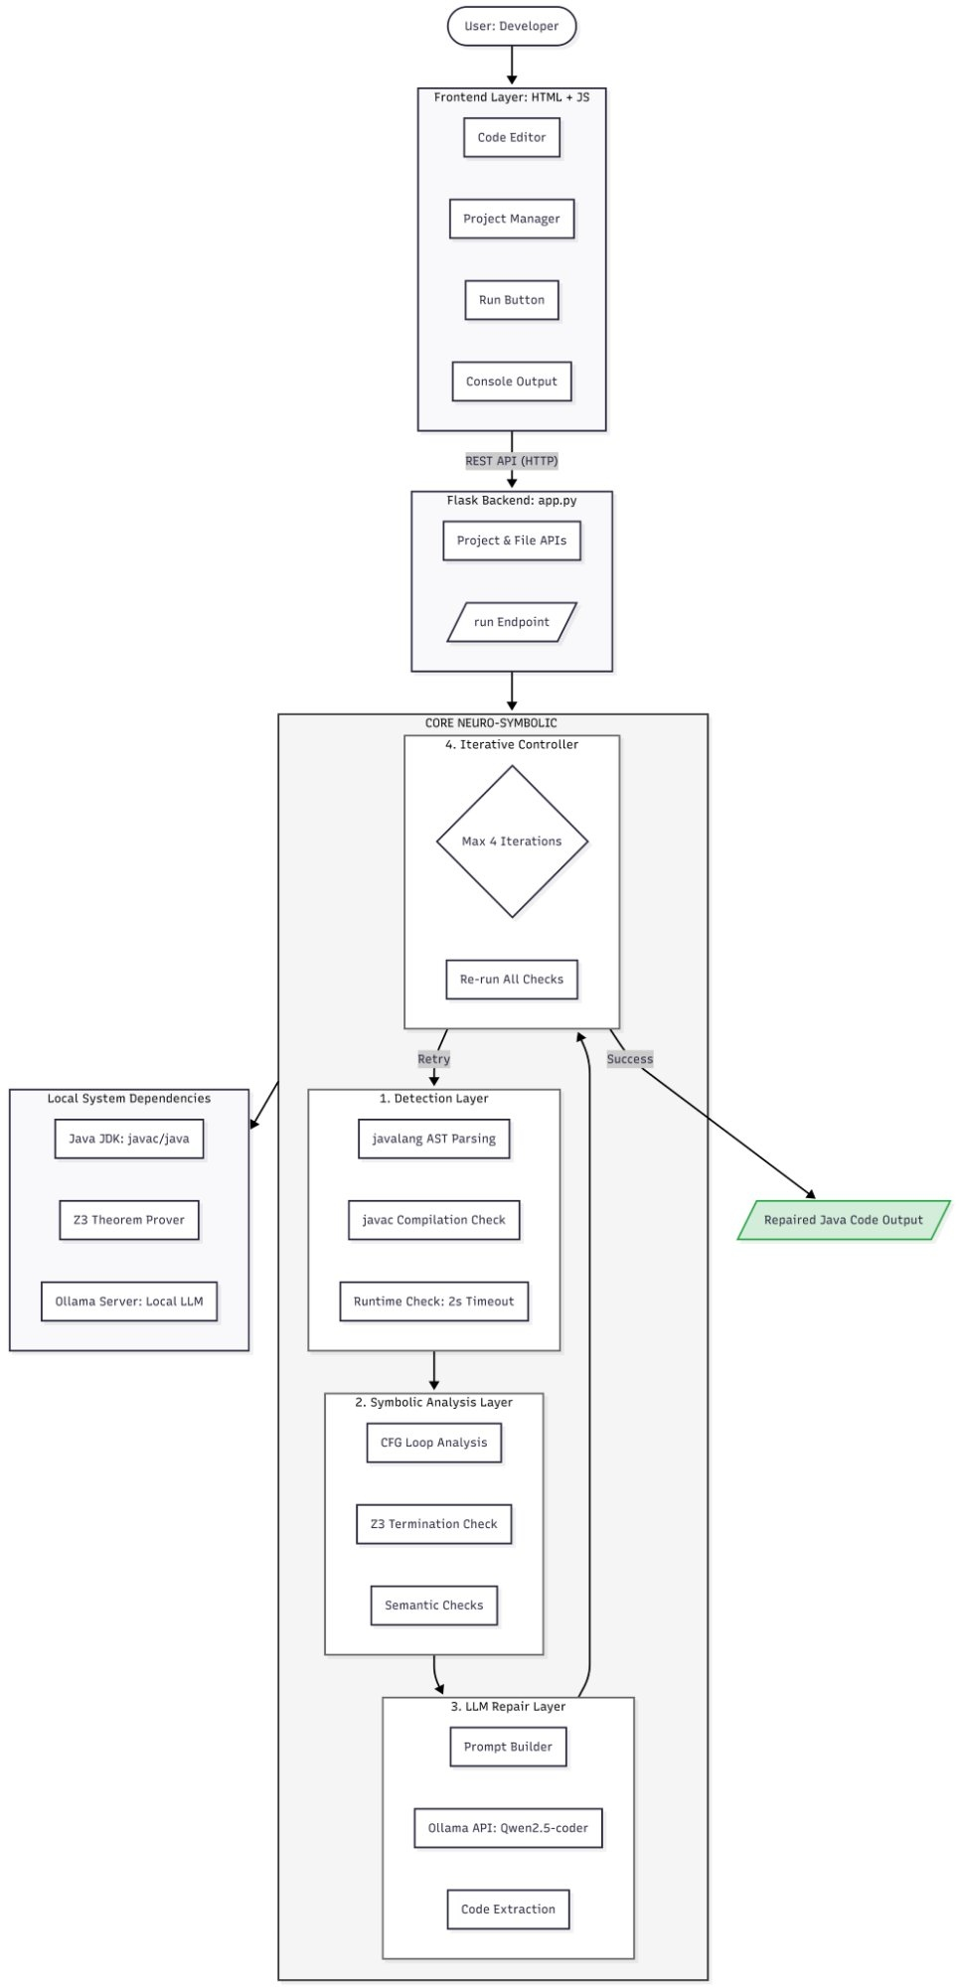
Fig. 1. Complete Architecture Diagram.
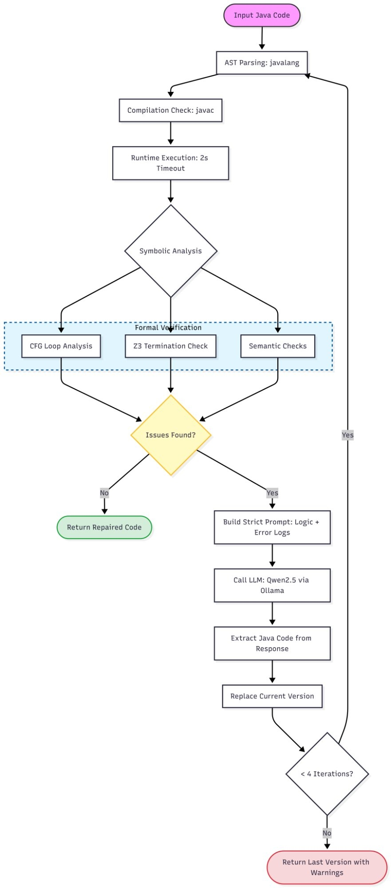
Fig. 2. Detailed Core Processing Engine.

B. System Implementation
Everything runs through a single Flask app, app.py. It handles RESTful endpoints—project creation, file management (create, read, update, delete), folder creation, and triggering AutoFixer repairs. Project metadata lives as JSON files inside a local projects/ directory. CORS support comes from flask-cors. The frontend is just HTML and JavaScript (Index.html and Script. No authentication or database server is required. Fig. 3 shows the deployment architecture.
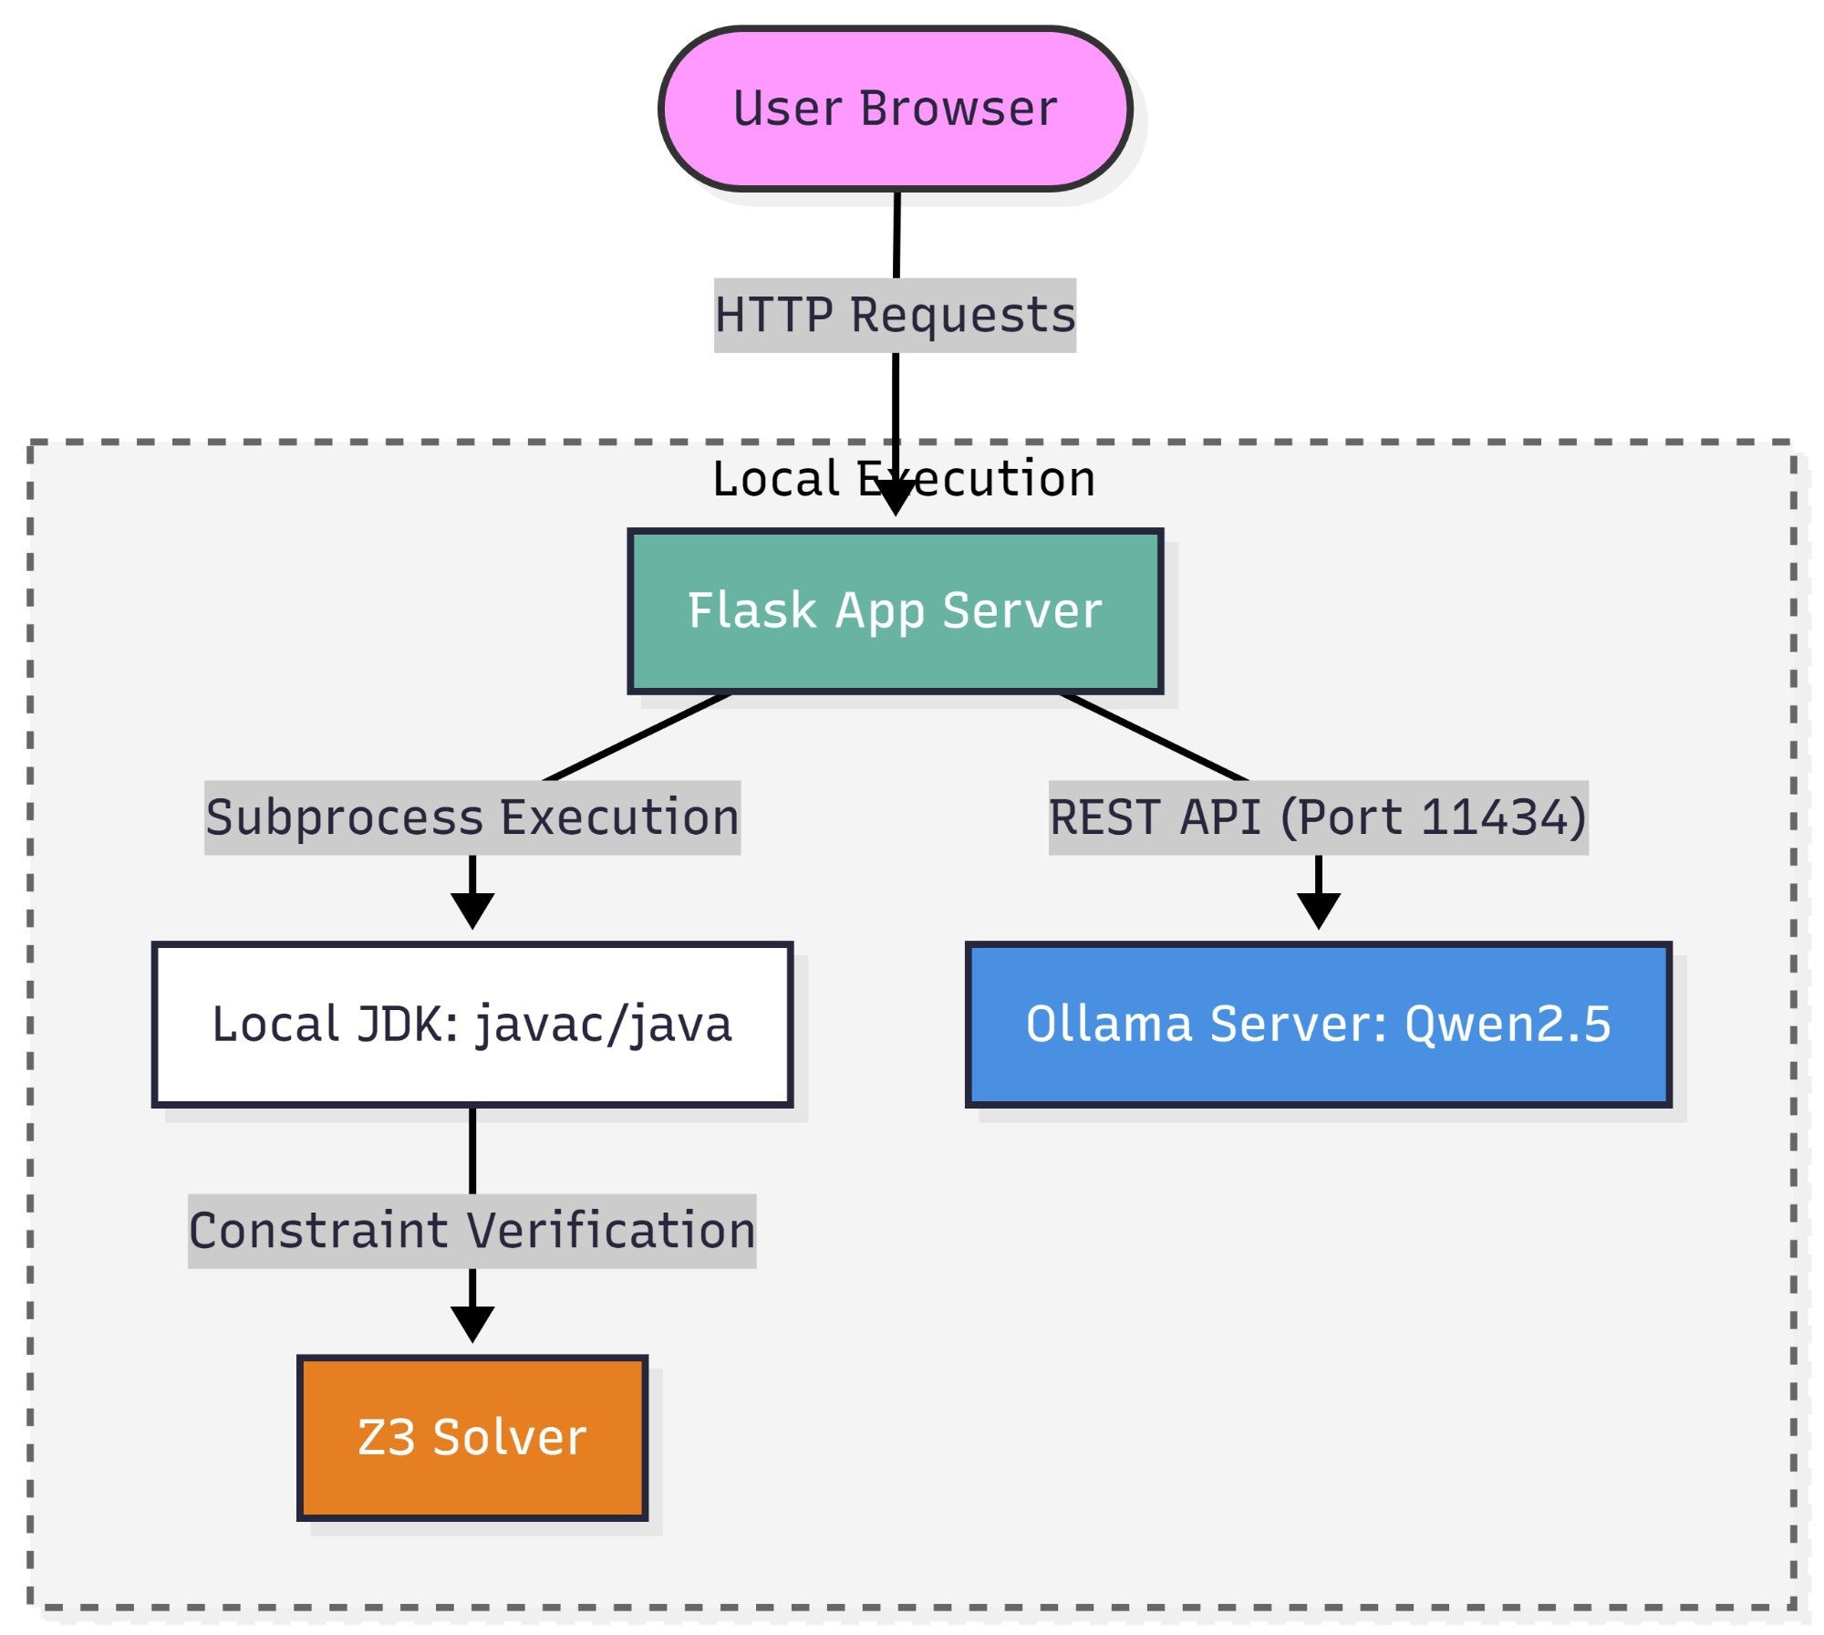
Fig. 3. Deployment Architecture.
C. System Workflow
AutoFixer runs through four main phases, looping as needed until it fixes the code or hits its limit. Here’s how it works:
First comes detection. It calls compile_check() to run javac, then runtime_check() to execute the program. If the code hangs, say in an infinite loop, the runtime check kills it after two seconds.
Next, symbolic analysis kicks in. cfg_loop_analysis() looks for loop variables that never change or get skipped by continue. Then, z3_termination_check() uses Z3 to check if loop bounds are linear. semantic_checks() spots bad initializations, like setting max to 0 when the inputs could go negative.
After that, the LLM repair phase starts. The system creates a prompt listing all the issues it found and sends it to Qwen2.5-coder:3b via Ollama. extract_java() then cleans up the response, stripping out any text that isn’t valid Java code.
Finally, the iteration and output phase. The system swaps in the repaired code and runs the checks again. This loop can repeat up to four times, stopping early if everything passes. If not, it gives up after the fourth round.
V. Requirements Analysis
A. Functional Requirements
The system provides Java code analysis identifying syntax errors through compilation, semantic errors via static analysis, and runtime errors through subprocess execution. A single repair candidate is generated per iteration at temperature 0, repeated for up to 4 iterations. Every patch undergoes Z3-based formal verification. The HTML/JavaScript interface supports project management and repair triggering via POST /api/projects/<id>/run.
B. Non-Functional Requirements
The runtime_check() enforces a strict 2-second timeout for each attempt. The system supports single-user local deployment; multi-user concurrency is a future goal. All Flask endpoints return structured JSON error responses. No user authentication is currently implemented; JWT and rate limiting are planned.
C. System Constraints
The system is limited to Java source code repair. LLM integration depends on the local Ollama server running Qwen2.5-coder:3b (2–4 GB RAM required). Z3 verification is limited to linear loop patterns and simple AST-level semantic checks. Java JDK must be installed locally. No user data is transmitted externally, minimizing GDPR obligations.
VI. Results and Output
The system was evaluated on representative buggy Java programs. Fig. 4 shows the frontend submitting a buggy program to the Flask backend. Fig. 5 and Fig. 6 show the corrected code returned in the console panel after the neuro-symbolic pipeline completes. In every test, the system nailed the bug category and produced Java code that compiled and ran safely, all within just four tries.
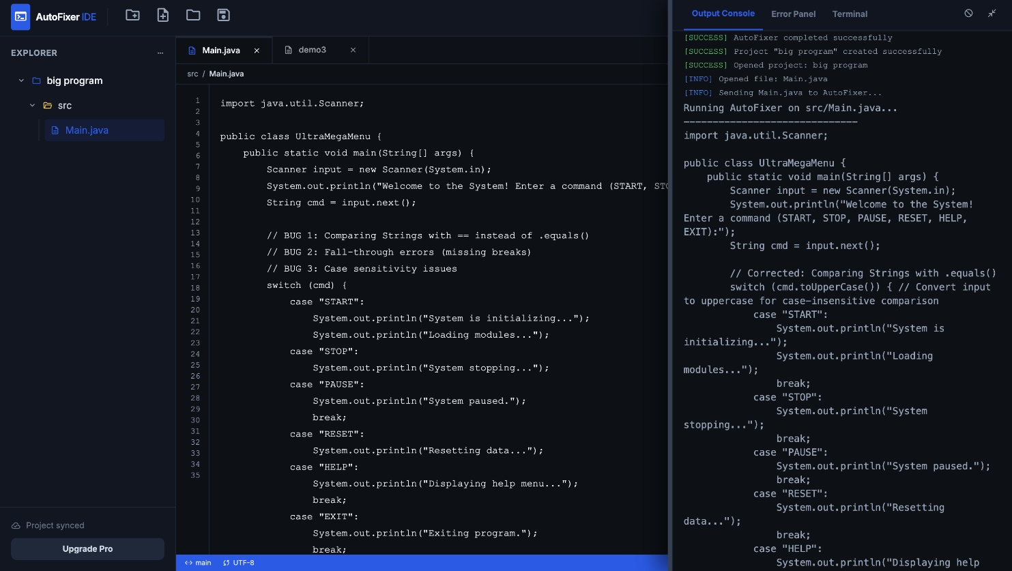
Fig. 4. Sending Program to Backend.
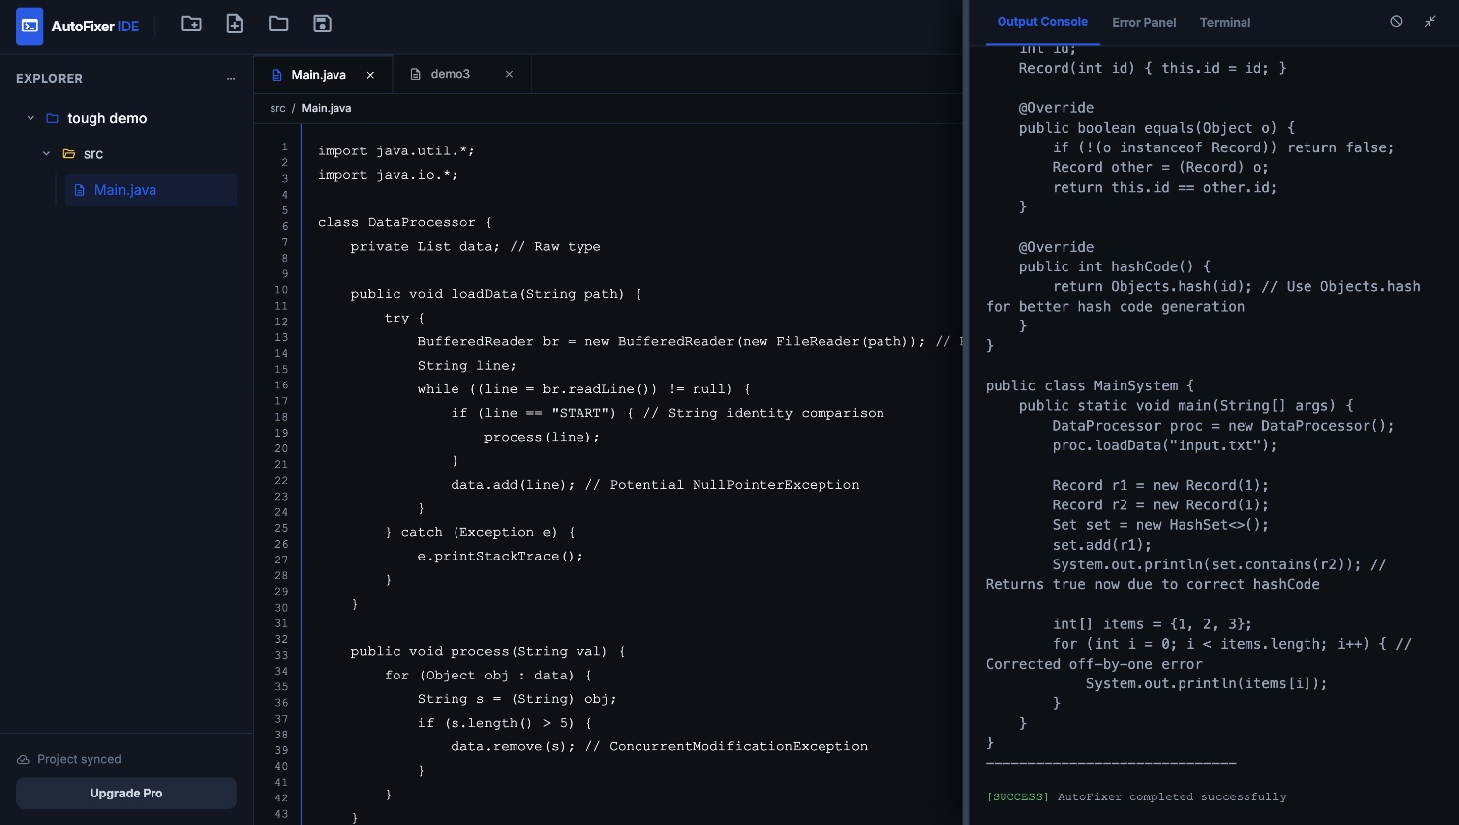
Fig. 5. Fixed Code Received (1).
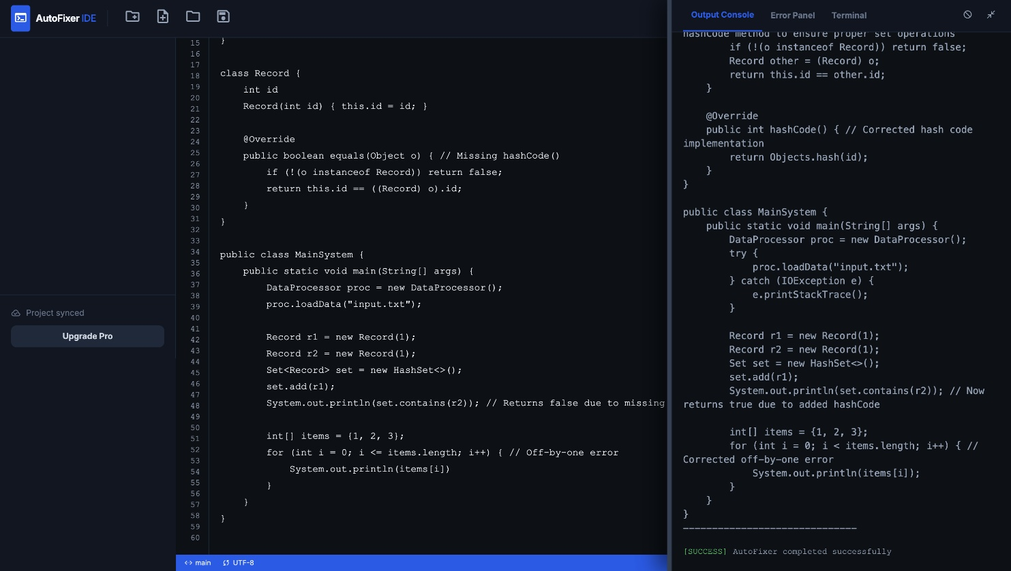
Fig. 6. Fixed Code Received (2).
VII. System Testing
Testing covered everything, both piece by piece and as a whole. The team checked four main areas: unit tests for single functions, integration tests for the entire repair pipeline, API tests for every Flask endpoint, and full end-to-end runs through the frontend.
A. Unit Testing — parse_ast()
TABLE I
parse_ast() Unit Test Results
Test Case | Input | Expected Output | Result
TC-01 | Valid Java class with main method | AST returned, error = None | Pass
TC-02 | Missing closing brace | AST = None, error string | Pass
TC-03 | Empty string | AST = None, error string | Pass
TC-04 | Class with while loop | AST with WhileStatement node | Pass

B. Integration Testing — fix_java_code()
TABLE II
fix_java_code() Integration Test Results
Test Case | Scenario | Expected Behaviour | Result
TC-23 | Infinite loop via continue | Fixed by iteration 2 | Pass
TC-24 | max = 0 with negative array | Corrected to Integer.MIN_VALUE | Pass
TC-25 | Missing semicolon | Compiles after LLM fix | Pass
TC-26 | Already correct code | Returned, no LLM call | Pass
TC-27 | Unfixable in 4 iterations | Best version returned | Pass

C. API Testing
TABLE III
Flask API Endpoint Test Results
Test Case | Endpoint | Expected Response | Result
TC-28 | POST /api/projects | 201 Created, metadata | Pass
TC-29 | GET /api/projects | 200 OK, project list | Pass
TC-32 | POST /<id>/run | 200 OK, repaired code | Pass
TC-33 | POST /run, no filePath | 400 Bad Request | Pass
TC-34 | DELETE /api/projects/<id> | 200 OK, dir removed | Pass

D. End-to-End System Testing
TABLE IV
End-to-End System Test Results
Test Case | Scenario | Expected Result | Result
TC-36 | Buggy file submitted | Repaired code in console | Pass
TC-37 | Correct code submitted | Returned unchanged | Pass
TC-38 | Empty file submitted | AST parse error | Pass
TC-39 | Non-existent filePath | 404 error returned | Pass
TC-40 | Ollama offline | Graceful error returned | Pass

All 40 test cases across all four categories passed successfully, confirming the reliability and correctness of each system component.
VIII. Conclusion
AutoFixer demonstrates the practical viability of neuro-symbolic reasoning for automated Java program repair. By combining AST parsing, CFG-based loop dominance analysis, Z3 theorem proving, and semantic validation with the generative capability of Qwen2.5-coder:3b via Ollama, the system directly addresses the core “plausible but incorrect” patch problem.
The iterative repair loop running up to 4 cycles of detect, analyze, repair, and verify ensures patches are not blindly accepted but re-validated after each LLM-generated fix. The single-application Flask architecture proves that a capable neuro-symbolic repair tool does not require cloud infrastructure or expensive API subscriptions, making it genuinely accessible to students and small development teams.
Future work includes multi-file support, configurable runtime timeouts, user authentication with repair history, expanded symbolic checks for for-loops and recursive methods, confidence-based iteration control, multi-language support, and cloud deployment for multi-user access.
References
[1] W. Weimer, T. Nguyen, C. Le Goues, and S. Forrest, "Automatically finding patches using genetic programming," in Proc. 31st ICSE, 2009, pp. 364-374.
[2] D. Kim, J. Nam, J. Song, and S. Kim, "Automatic patch generation learned from human-written patches," in Proc. 35th ICSE, 2013, pp. 802-811.
[3] X. B. D. Le, D. Lo, and C. Le Goues, "History driven program repair," in Proc. IEEE 23rd SANER, 2016, pp. 213-224.
[4] H. D. T. Nguyen, D. Qi, A. Roychoudhury, and S. Chandra, "SemFix: Program repair via semantic analysis," in Proc. 35th ICSE, 2013, pp. 772-781.
[5] S. Mechtaev, J. Yi, and A. Roychoudhury, "DirectFix: Looking for simple program repairs," in Proc. 37th ICSE, 2015, pp. 448-458.
[6] Y. Yuan and W. Banzhaf, "ARJA: Automated repair of Java programs via multi-objective genetic programming," IEEE Trans. Softw. Eng., vol. 46, no. 10, pp. 1040-1067, 2020.
[7] M. Martinez and M. Monperrus, "Mining software repair models for reasoning on the search space of automated program fixing," Empirical Softw. Eng., vol. 20, no. 1, pp. 176-205, 2015.
[8] J. Kim, J. Jung, K. Kim, and S. Yoo, "Human-written patch learning for automated program repair," in Proc. 41st ICSE, 2019, pp. 1220-1230.
[9] F. Long and M. Rinard, "Automatic patch generation by learning correct code," ACM SIGPLAN Notices, vol. 51, no. 1, pp. 298-312, 2016.
[10] M. Chen et al., "Evaluating large language models trained on code," arXiv:2107.03374, 2021.
[11] N. Jiang, K. Liu, T. Lutellier, and L. Tan, "Impact of code language models on automated program repair," in Proc. 45th ICSE, 2023, pp. 1430-1442.
[12] C. S. Xia and L. Zhang, "Keep the conversation going: Fixing 162 out of 337 bugs for $0.42 each using ChatGPT," arXiv:2304.00385, 2023.
[13] C. E. Jimenez et al., "SWE-bench: Can language models resolve real-world GitHub issues?" arXiv:2310.06770, 2023.
[14] M. Yan, J. Xuan, and M. Monperrus, "Neural program repair: Systems, challenges and solutions," in Proc. IEEE ICSME, 2020, pp. 615-626.
[15] S. Chakraborty, R. Krishna, Y. Ding, and B. Ray, "Deep learning based vulnerability detection: Are we there yet?" IEEE Trans. Softw. Eng., vol. 48, no. 9, pp. 3280-3296, 2022.
[16] H. Wang, J. Xuan, and M. Monperrus, "FixMiner: Mining relevant fix patterns for automated program repair," Empirical Softw. Eng., vol. 25, no. 6, pp. 5089-5115, 2020.
[17] M. Tufano et al., "An empirical study on learning bug-fixing patches in the wild via neural machine translation," ACM Trans. Softw. Eng. Methodol., vol. 28, no. 4, pp. 1-29, 2019.
[18] T. Ahmed, N. A. Kraft, and P. Devanbu, "Empirical study of automated program repair techniques," in Proc. 43rd ICSE, 2021, pp. 1204-1215.
[19] J. Zhang et al., "Syntax-guided program repair using genetic programming," IEEE Trans. Softw. Eng., vol. 46, no. 11, pp. 1249-1264, 2020.
[20] R. Just, D. Jalali, and M. D. Ernst, "Defects4J: A database of existing faults to enable controlled testing studies for Java programs," in Proc. ISSTA, 2014, pp. 437-440.
[21] D. Lin, J. Kinder, and D. Dig, "QuixBugs: A multi-lingual program repair benchmark set," in Proc. 11th FSE, 2017, pp. 55-65.
[22] H. Ye, J. Chen, and L. Tan, "An empirical study of automated program repair on the QuixBugs benchmark," in Proc. 43rd ICSE, 2021, pp. 1374-1385.
[23] Z. Qi, F. Long, S. Achour, and M. Rinard, "An analysis of patch plausibility and correctness for generate-and-validate patch generation systems," in Proc. ISSTA, 2015, pp. 24-36.
[24] E. K. Smith and M. C. Rinard, "The automated program repair landscape," in Proc. 40th ICSE, 2018, pp. 658-669.
[25] M. Monperrus, "Automatic software repair: A bibliography," ACM Comput. Surv., vol. 51, no. 1, pp. 1-24, 2018.
[26] J. A. Prenner, H. Babii, and R. Robbes, "Can OpenAI Codex and other large language models help us fix bugs?" arXiv:2112.09344, 2021.
[27] J. Bader, A. Scott, M. Pradel, and S. Chandra, "Getafix: Learning to fix bugs automatically," Proc. ACM Program. Lang., vol. 3, OOPSLA, pp. 1-27, 2019.
[28] D. Sobania, M. Briesch, C. Hanna, and J. Petke, "An analysis of the automatic bug fixing performance of ChatGPT," arXiv:2301.08653, 2023.

